Result :
My demo flow which actually work :--
Message → Kinesis Stream → Lambda → CloudWatch Logs

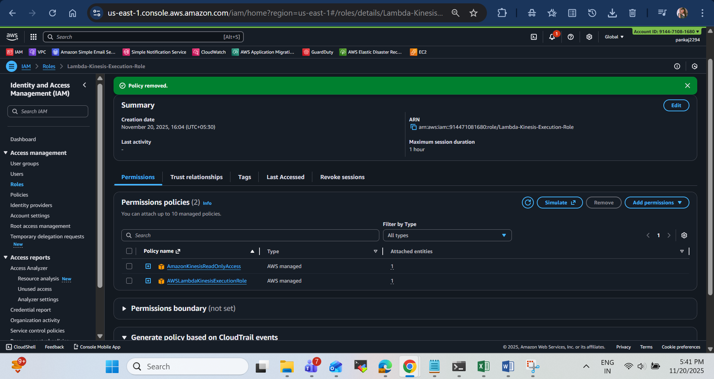

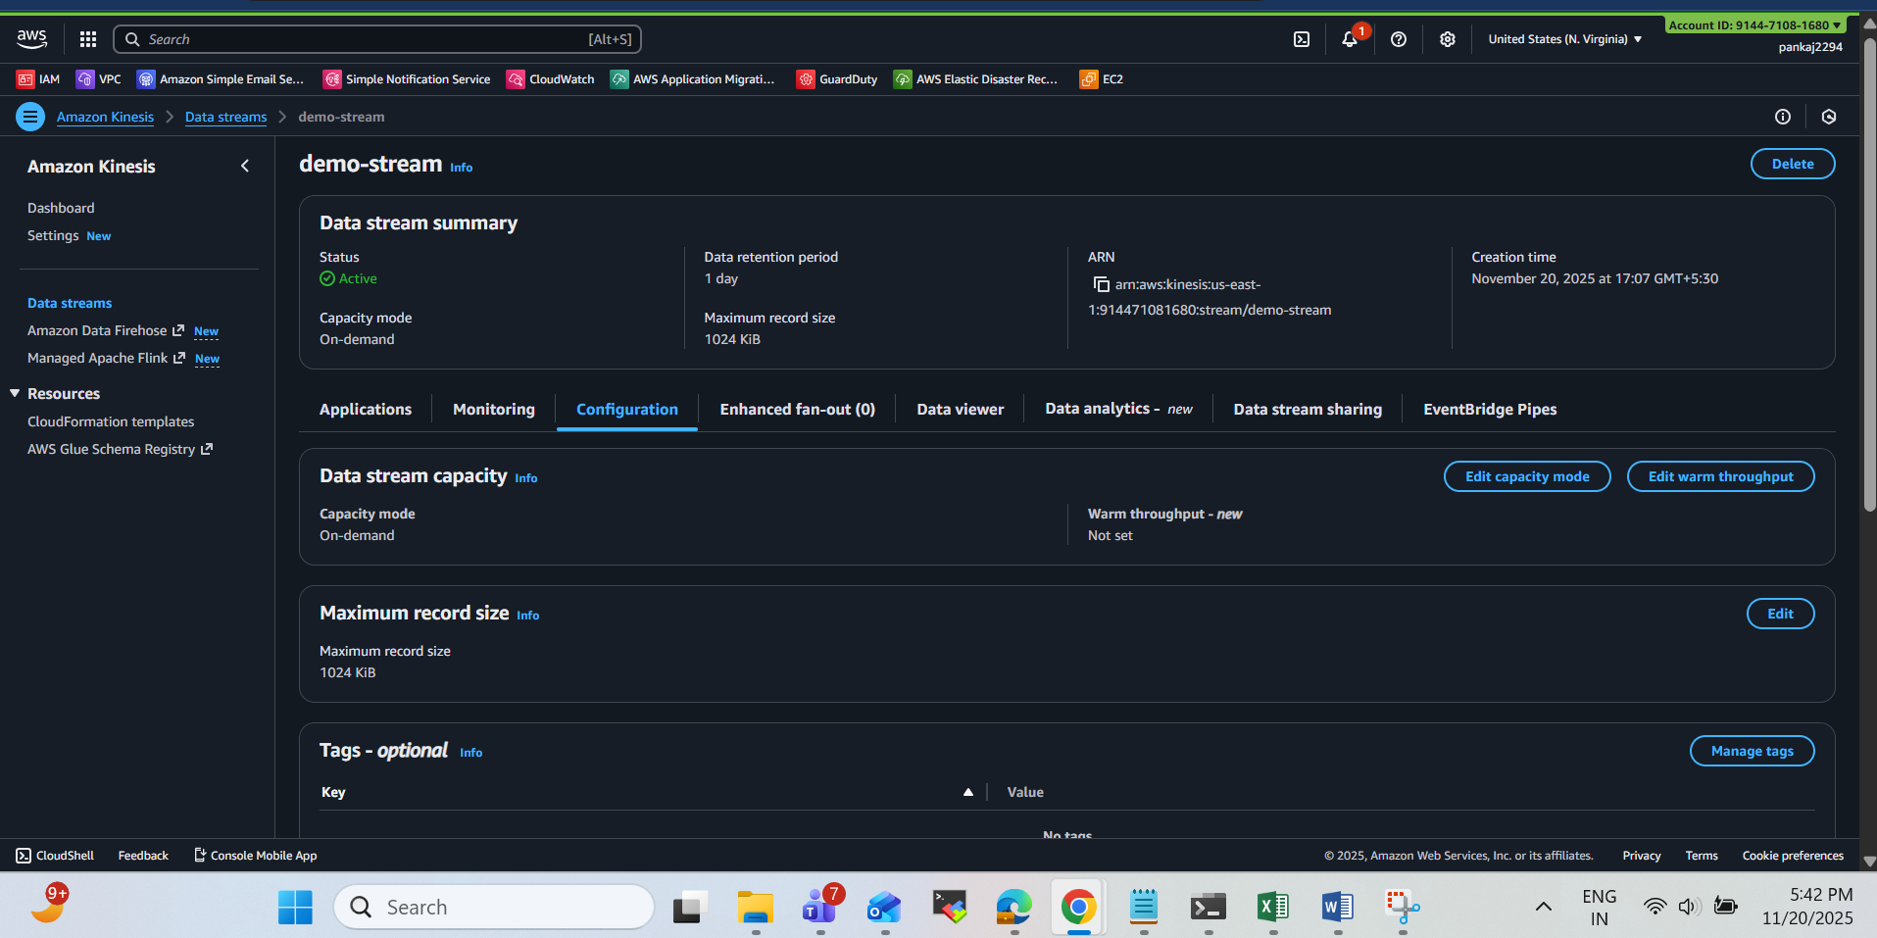

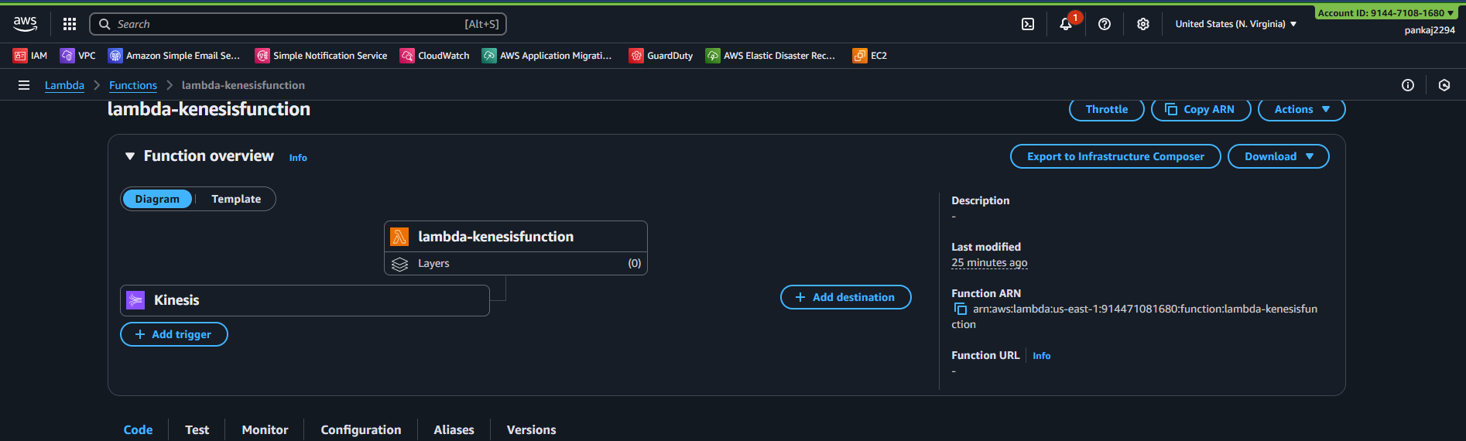
Code I have deployed in lambda code:
import base64

def lambda_handler(event, context):
for record in event['Records']:
payload = base64.b64decode(record['kinesis']['data']).decode('utf-8')
print("Decoded Payload:", payload)
return {"status": "done"}

code with output :
